N4DIG08 Modbus RTU Protocol(8 Output)
MODBUS command (function code 06 is Control command,03 is Read status command)

Note :
1 MODBUS command must be HEX
2 Slave ID (device address) must be correct, the default slave address is 01, and the Slave ID is set to see the bottom.
3 If you don't remember the Slave ID, use the command Read Slave ID : FF 03 00 FE 00 01 F0 24

As an 8-channel output function, the jumper must be shorted as follows: 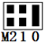

9600 Band ,8 Data bits,None Parity,1 Stop Bit。

Function code
RS485 address  (Station address)  (1) | Function (1) | Register address (2) | Read number (2) | CRC16 (2)
 | 03 Read
 | 06 Write
16(0x10)
Write multiple registers

Function code | Register address | Register contents | Number of bytes | Register value | Remarks
03 06  16(0X10) | 0x0001-0x0008 | Output port status | 2 | 0X0000  0X0001 | 0X0000 Relay Close  0X0001 Relay Open
03 06 | 0x00FA  (250) | Onput level | 2 | 0X0000  0X0001 | 0X0000 PNP Low level output (default)  0X0001 NPN High level onput
03 06 | 0x00FE | Baud rate | 2 | 0x0000-0x0005 | 0~5 0:1200  1:2400 2:4800  3:9600（default）  4:19200  5: Factory reset
03 06 | 0x00FF | Baud rate | 2 |  | 0~4 0:1200  1:2400 2:4800  3:9600（default）  4:19200  5: Factory reset

MODBUS 06 Command (Control command ,HEX):
Bytes Number | 1 | 2 | 3 | 4 | 5 | 6 | 7 | 8
MODBUS Definitions | Slave ID | Function | Address |  | Data |  | CRC Check
Function | Device Address | Function | Channel number |  | Command | Delay time | CRC Check
Open | 0x00-0x2F | 0x06 | 0x0001-  0x0008 |  | 0x01 | 0x00 | 2Bytes CRC
Close | 0x00-0x2F | 0x06 | 0x0001-  0x0008 |  | 0x02 | 0x00 | 2Bytes CRC
Toggle (Self-locking) | 0x00-0x2F | 0x06 | 0x0001-  0x0008 |  | 0x03 | 0x00 | 2Bytes CRC
Latch Inter-locking) | 0x00-0x2F | 0x06 | 0x0001-  0x0008 |  | 0x04 | 0x00 | 2Bytes CRC
Momentary (Non-locking) | 0x00-0x2F | 0x06 | 0x0001-  0x0008 |  | 0x05 | 0x00 | 2Bytes CRC
Delay | 0x00-0x2F | 0x06 | 0x0001-  0x0008 |  | 0x06 | 0x00-0xff | 2Bytes CRC
Open all | 0x00-0x2F | 0x06 | 0x0000 |  | 0x07 | 0x00 | 2Bytes CRC
Close all | 0x00-0x2F | 0x06 | 0x0000 |  | 0x08 | 0x00 | 2Bytes CRC
Remarks:
1 Momentary mode, delay time is 1 seconds
2 Delay mode, delay time is 0-255 seconds

Return command：
Command is active, return to send commands; instruction is invalid no return.

MODBUS 03 Command (Read status command ,HEX):
Bytes Number | 1 | 2 | 3 | 4 | 5 | 6 | 7 | 8
MODBUS Definitions | Slave ID | Function | Address |  | Data |  | CRC Check
Function | Device Address | Function | Starting register address |  | Register length |  | CRC Check
Read Channel 1 State | 0x00-0x2F | 0x03 | 0x0001 |  | 0x0001
Read Channel 2 State | 0x00-0x2F | 0x03 | 0x0002 |  | 0x0001
Read 2 consecutive channels status | 0x00-0x2F | 0x03 | 0x0001-0x0003 |  | 0x0002
Read 3 consecutive channels status | 0x00-0x2F | 0x03 | 0x0001-0x0002 |  | 0x0003
Read all 8 channels status | 0x00-0x2F | 0x03 | 0x0001 |  | 0x0008

Read status command returns (function code 03, HEX format):
Bytes length | 1 | 1 | 1 |  | 2
MODBUS Definitions | Slave ID | Function | data length | data | CRC16 Check
Function | Device Address | Function | data length | Relay state  0x0001 open  0x0000 close | CRC16 Check
Channel 1  open | 0x00-0x1F | 0x03 | 0x02 | 0x0001
Channel 1  close | 0x00-0x1F | 0x03 | 0x02 | 0x0000
Channel 2  open | 0x00-0x1F | 0x03 | 0x02 | 0x0001
Channel 2  close | 0x00-0x1F | 0x03 | 0x02 | 0x0000
Channel 1 open  Channel 2 open | 0x00-0x1F | 0x03 | 0x04 | 0x0001 0x0001
Channel 1 open  Channel 2 close | 0x00-0x1F | 0x03 | 0x04 | 0x0001 0x0000
Channel 1 close  Channel 2 open | 0x00-0x1F | 0x03 | 0x04 | 0x0000 0x0001
Channel 1 close  Channel 2 close | 0x00-0x1F | 0x03 | 0x04 | 0x0000 0x0000

MODBUS commands you can use "Modbus Poll" input, as shown below
（CRC check generated automatically）
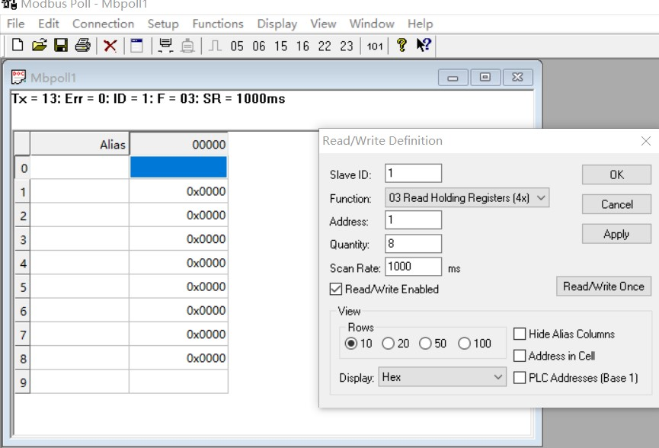
You can also use HyperTerminal serial input, as shown below
（Manually add CRC check）
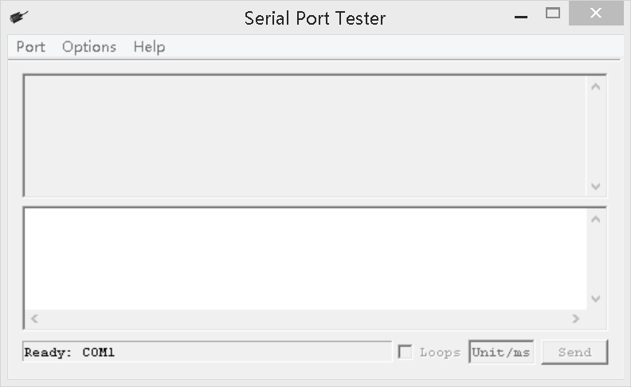


Examples
Channel 1 Open ：01 06 00 01 01 00 D9 9A
Channel 1 Close ：01 06 00 01 02 00 D9 6A
Channel 1 Toggle：01 06 00 01 03 00 D8 FA
Channel 1 Latch：01 06 00 01 04 00 DA CA
Channel 1 Momentary: 01 06 00 01 05 00 DB 5A
Channel 1 Delay 10 seconds : 01 06 00 01 06 0A 5B AD
Channel 1 Delay 100 seconds: 01 06 00 01 06 64 DA 41

Channel 2 Open ：01 06 00 02 01 00 29 9A
Channel 2 Close ：01 06 00 02 02 00 29 6A
Channel 2 Toggle ：01 06 00 02 03 00 28 FA
Channel 2 Latch ：01 06 00 02 04 00 2A CA
Channel 2 Momentary : 01 06 00 02 05 00 2B 5A
Channel 2 Delay 10 seconds : 01 06 00 02 06 0A AB AD
Channel 2 Delay 100 seconds : 01 06 00 02 06 64 2A 41

Read state (assuming that the channel 1 is open, the channel 2 is close).
Read channel 1 state ：01 03 00 01 00 01 D5 CA
Return open：01 03 02 00 01 79 84

Read channel 2 state ：01 03 00 02 00 01 25 CA
Return close：01 03 02 00 00 B8 44

Read channel 1 and channel 2 state ：01 03 00 01 00 02 95 CB
Return channel open and channel 2 close ：01 03 04 00 01 00 00 AB F3

- Read Onput level selection register
Send data
RS485 address  (Station address)  (1) | Function (1) | Register address (2) | Read number (2) | CRC16(2)

Returns data
RS485 address  (Station address)  (1) | Function (1) | Number of bytes (1) | data (n) | CRC16(2)
RS485 address:0x01-0xFE
Function code 0x03
Register address：0x00FA
Read number：0x0001

For example:
send data(RS485 address is 1)：01 03 00 FA 00 01 A4 3B
Returns data 1 ：01 03 02 00 00 B8 44 PNP low level output (default)
Returns data 2 ：01 03 02 00 01 79 84 NPN high level output
- Set Onput level selection register (8 channels set at the same time)
Send data
RS485 address  (Station address)  (1) | Function (1) | Register address (2) | Setting Content (2) | CRC16(2)

Returns data
RS485 address  (Station address)  (1) | Function (1) | Register address  (2) | Register value (2) | CRC16(2)
RS485 address:0x01-0xFE
Function code 0x06
Register address：0x00FA
Setting Content：1Bytes
0X0000 Low level output (default): Low level is valid output, high level is invalid output 0X0001 High level output: high level valid output, low level invalid output

Set low level input(PNP):
Send data (RS485 address is 1) 01 06 00 FA 00 00 A9 FB
Return data: 01 06 00 FA 00 00 A9 FB
Set high level input(NPN):
Send data (RS485 address is 1) 01 06 00 FA 00 01 68 3B
Return frame: 01 06 00 FA 00 01 68 3B

- Read RS485 address
Send data
RS485 address  (Broadcast address)  (1) | Function (1) | Register address (2) | Read number (2) | CRC16(2)

Returns data
RS485 address  ( Broadcast address )  (1) | Function (1) | Number of bytes (1) | data (n) | CRC16(2)

Broadcast address 0xff
Function code 0x03
Register address：0x00FE
Read number：0x0001

For example:
send data：FF 03 00 FE 00 01 F0 24
Returns data：FF 03 02 00 01 50 50
FF Broadcast address，03 Function，02 length，01 is the current module RS485 address , 50 50 crc16
Note: When using this command, only one temperature module can be connected to the RS485 bus, more than one will be wrong!

- Write RS485 address
Send data
RS485 address  (Station address)  (1) | Function (1) | Register address (2) | Setting Content (2) | CRC16(2)

Returns data
RS485 address  (Station address)  (1) | Function (1) | Register address  (2) | Register value (2) | CRC16(2)
RS485 address(Slave ID) : 0x01~0xFE
Function code 0x06
Register address：0x00FE
Setting Content：2Bytes(1-247)

For example, The current RS485 address is 1, We need to change the RS485 address to 3:
send data(RS485 address is 1)：01 06 00 FE 00 03 A8 3B
Returns data：01 06 00 FE 00 03 A8 3B

- Read baud rate
Send data
RS485 address  (Station address)  (1) | Function (1) | Register address (2) | Read number (2) | CRC16(2)

Returns data
RS485 address  (Station address)  (1) | Function (1) | Number of bytes (1) | data (n) | CRC16(2)
RS485 address(Slave ID) : 0x01~0xFE
Function code 0x03
Register address：0x000FF
Read number：0x0001
For example:
send data(RS485 address is 1)：01 03 00 FF 00 01 B4 3A
Returns data：01 03 02 00 03 F8 45
01 RS485 address，03 Function，02 length，F8 45 crc16
03 means the current baud rate is 9600bps
Baud rate corresponds to the number: 0: 1200 1: 2400 2: 4800 3: 9600 4: 19200

- Write RS485 address
Send data
RS485 address  (Station address)  (1) | Function (1) | Register address (2) | Setting Content (2) | CRC16(2)

Returns data
RS485 address  (Station address)  (1) | Function (1) | Register address  (2) | Register value (2) | CRC16(2)
RS485 address(Slave ID) : 0x01~0xFE
Function code 0x06
Register address：0x00FF
Setting Content：2Bytes(0-4)

For example, Change the baud rate to 4800bps:
send data(RS485 address is 1)：01 06 00 FF 00 02 38 3B
Returns data：01 06 00 FF 00 02 38 3B
Baud rate corresponds to the number: 0: 1200 1: 2400 2: 4800 3: 9600 4: 19200
5: Factory reset
Note: 1 The baud rate will be updated when the module is powered up again!
2 The factory setting can be restored when the baud rate corresponding to the number is 5. For example: 01 06 00 FF 00 05 79 F9

